
2001 Issues
September
June
March
2000 Issues
December
September
June
March
Previous Issues
1999-1998
Subscribe Now

Autopilot design using Mu Analysis and Synthesis
by Rick Hyde and Jeremy Hodgson
This article illustrates the application of H-infinity loop-shaping to a missile autopilot. The H-infinity loop-shaping control design method can handle complex coupled systems and is supported by the Mu Analysis and Synthesis Toolbox. It is easy to pick up by engineers with a basic background in classical control.
All files associated with the article can be obtained as a ZIP Archive.
Introduction
MATLAB provides a powerful tool for control design in that it enables the designer to experiment with different design methods, and to understand the fundamental control constraints of a particular system. At our UK MathWorks office, we have experience in applying a range of design methods to a variety of different applications. One of the most appealing methods for our customers, and one which yields good designs is the H-infinity loop-shaping approach. The term H-infinity refers to the particular mathematical foundation used behind the method. However, an understanding of this is not required to apply the method when using the Mu Analysis and Synthesis Toolbox.
This article illustrates the application of H-infinity loop-shaping to a missile autopilot. The files used can be downloaded and tailored for other applications. The H-infinity loop-shaping design method is an extension of classical loop-shaping. Essentially classical loop-shaping is carried out to specify the bandwidth, low-frequency gain and high-frequency rolloff, and then an optimal stabilizing compensator is synthesized using the H-infinity method. The H-infinity optimization returns a number which indicates what robustness margin is achievable for the performance specified. The power of the method is that it can simultaneously and reliably stabilize several feedback loops which may interact with each other. An application of the method to such a system can be found in reference [1] where a flight control law was designed and flight tested on a research aircraft.
There are a number of desirable attributes a designer will look for from a control design method. Typically these could include:
 | • | Fitting the overall design process. For example, in aerospace applications, experience has shown that pure linear control is inadequate, and so some kind of gain scheduling and/or nonlinear control is required. Hence for a linear design method to fit the overall design process, easy gain scheduling must be possible.
 | • | Easy tradeoff of performance and robustness. The system requirements will typically specify a minimum robustness requirement; e.g., in terms of worst gain and phase margins over the operating envelope (which may include specified uncertainties). A good design method will enable the designer to just meet this requirement whilst maximizing achievable performance.
 | • | Systematic handling of complexity. More recent airframes have more control surfaces, and more cross-axis coupling due to unusual aerodynamic shapes. Effective use of all surfaces and appropriate control law structure selection are becoming harder to achieve in a systematic way when using traditional methods.
 | • | Finding the best solution. Given the airframe fundamental constraints (e.g. fin sizing and fin actuator performance), the designer needs to extract as much performance as possible. A method which can find the best solution is clearly desirable. A method which is guaranteed to find the best solution is even better.
 | • | Complexity/performance tradeoff. A controller which is complex to implement, and which provides minimal benefit over another much simpler design, is clearly undesirable. An ideal method would allow the designer to set complexity (e.g. the controller architecture or order) as a constraint.
H-infinity loop-shaping scores well on items 2,3 and 4 compared to many other methods. However, the resulting controller is typically more complex to implement than a conventional classical PID controller, and hence should only be used when it can be shown that it has a significant robustness and/or performance benefit. There is much debate in the aerospace industry as to whether the classical approach can be extended to more complex cross-coupled airframes. One way to achieve this is to make increased use of intelligent tools written in MATLAB which do the design iteration to balance performance and robustness requirements. However, for some airframes, the classical control law structure is just not sufficient to extract the most performance from the airframe. As a general rule, the controller structure must mirror the structure of the plant. Hence if the plant is highly cross-coupled and requires high order for accurate modeling, then so does the controller to extract the maximum performance/robustness.
Missile Example
This example is taken from reference [2] which gives the nonlinear aerodynamics for single plane motion of a missile. The Simulink model which implements this is airframe.mdl. The model parameters are initialized by running guid_dat.m. The top level is shown below in Figure 1.
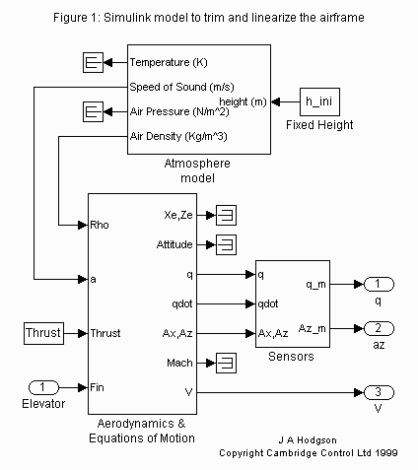
A model of this form can be linearized in two different ways. The traditional way is calculate aerodynamic derivatives directly from the aerodynamic look-up tables, and to piece the linearized model together term by term. Alternatively, the Simulink model can be trimmed and linearized directly using the Simulink supporting functions trim.m and linmod.m. This second approach is more generally applicable to other systems. The code required to do this is as follows:

[X_trim,U_trim,Y_trim,DX]=trim 'airframe',x0,[0]',[0 0 v_ini 0 0]',n_states,fixed_inputs,fixed_outputs,[],n_deriv);
[A,B,C,D]=linmod('airframe',X_trim,U_trim);

The setting up of the trim function needs careful thought as to exactly what the desired trim condition is. In this case we have set it to trim to a particular incidence and Mach number. Hence these attributes are defined as fixed by appropriate setting up of n_states . The trim algorithm is left free to determine what the other states, such as pitch rate (q), should be for the particular trim condition.
One of the complications when trimming and linearizing a Simulink model is that the ordering of the states within the model can change if the model is modified. This requires that the inputs to trim.m are modified accordingly. A way to avoid this issue is implemented in the file trim_airframe.m. The solution is to interrogate the model to find the state ordering by matching the Simulink block names to reference ones within the M-file.
Control Design Requirements
From exploring airframe.mdl you will see that the linearized dynamics will depend on Mach number, incidence and altitude. For the purposes of this paper, we will ignore the effect of altitude and assume all design is at sea level. This is usually a reasonable assumption as prescheduling (or normalizing) with dynamic pressure typically makes the effect of altitude negligible. The control task is to track acceleration demands using accelerometer and pitch gyro measurements. The robustness requirement is to achieve at least 40 degrees phase margin and 8 dB gain margin at the actuator, gyro and accelerometer. The performance requirement is to track the acceleration requirement as quickly as possible whilst meeting the gain and phase margin requirements. Large overshoot is undesirable as it could take the missile outside of its operating envelope (structural limits or incidence) when tracking large acceleration demands.
The designer has freedom to choose whether to schedule on Mach number and incidence. Scheduling on Mach number is generally a good idea where the missile operates over a wide range of speeds; e.g., an air-to-air missile which is typically launched subsonic and will reach several times the speed of sound. Scheduling on incidence is less straightforward as incidence can not be directly measured. Instead it has to be estimated from acceleration and knowledge of the nominal aerodynamics. The estimator will introduce a measurement lag which has to be accounted for in the design.
H-infinity Loop-Shaping Design
The H-infinity design method actually covers a multitude of design methods, all based on H-infinity theory. The Mu Analysis and Synthesis Toolbox provides easy access to these methods with only a modest background of H-infinity theory being required by the user. Cambridge Control has experience of applying these different H-infinity design methods to a range of applications including missiles. In our experience, one of the most reliable and easy to use methods is that of H-infinity loop-shaping, and this provides the basis for the work designed here.
As the name suggests, H-infinity loop-shaping is closely related to design using classical loop-shaping. The figure below shows a Simulink implementation of an H-infinity loop-shaping controller for our missile example. The Simulink model controlled_airframe.mdl contains both the plant and this controller.
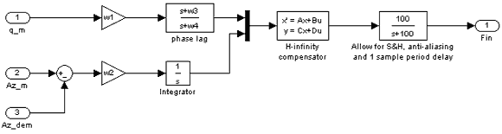
The inputs are the gyro measurement, the accelerometer measurement and the acceleration demand. The phase lag, integrator and gain blocks are terms which would appear in a classical autopilot and are tuned using the same rules of thumb. Typically, the gyro terms are designed first, with w1 being set to achieve as much pitch rate damping as possible whilst still achieving the required gain and phase margins. The acceleration gain w2 is then tuned to meet the required response time. The lag term is used to boost pitch rate damping at frequencies around and below the acceleration open-loop cross-over.
The H-infinity compensator block is the H-infinity stabilizing controller, and is found using Mu Analysis and Synthesis command ncfsyn.m. This finds a compensator which maximizes robustness to so-called normalized coprime factor uncertainty [3]. It has been shown [4] that this type of uncertainty has close relationships with the type of uncertainty captured by gain and phase margins for single loop feedback systems. For example, requiring 40 degrees of phase margin can be shown to be achieved if the coprime factor robustness measure is greater than 0.34. In multiloop feedback systems, gain and phase margins can be very unreliable indicators of robustness, whereas coprime factor uncertainty is not.
The design file for the missile is called lsdp.m. When this file is run, the user is asked to specify the open-loop cross-over at the gyro, the open-loop cross-over at the accelerometer, the upper frequency for the lag network, and the ratio of low to high frequency gain for the lag network. This information is then turned into the equivalent values for w1, w2, w3 and w4. The total system comprising the airframe, actuator dynamics, and classical controller terms is then constructed as a Mu Analysis and Synthesis state-space object, GsysWsys. The H-infinity controller and achieved robustness for these values is then calculated by calling ncfsyn.m:
[ksys,emax]=ncfsyn(GsysWsys,1.05);
ksys is the state-space implementation of the optimal H-infinity compensator, and emax is the robustness measure . Given our specification of 40 degrees phase margin, it can be shown that we need > 0.34. The design file lsdp.m is set up to let you iterate on the cross-over frequencies until this is achieved. For example, setting the gyro cross-over to 100 radians/s, the accelerometer cross-over to 30 radians/s, the upper lag frequency to 10 radians and the gain ratio to 10 achieves = 0.36. The figure below shows the resulting step response:
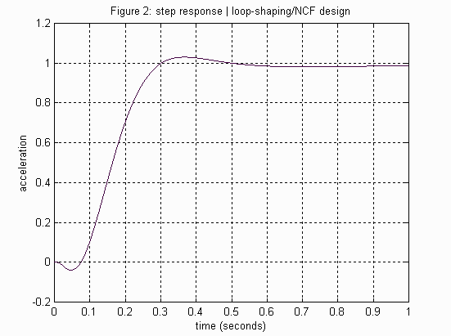
The controller ksys has seven states. This model is reduced to five states by calling the Mu Analysis and Synthesis model reduction function sncfbal.m:
[lcf,sig,rcf]=sncfbal(ksys);
% normalised coprime factorisation of ksys
rcf=sresid(rcf,5);
% keep 5 states
ksys_r=cf2sys(rcf);
% reconstruct the controller
k_error=nugap(ksys,ksys_r)
% model reduction error (in nu-gap metric)
The final line calculates the so-called -gap (see reference [4] for the original derivation) between the full order controller and the reduced order controller. The value of minus the value of the -gap gives a guaranteed level of robustness which will be achieved by the reduced order controller. Thus a -gap of around 0.02 or less will have minimal impact on the closed-loop stability. This is a very powerful and reliable way to model reduce high-order state-space controllers.
For complete envelope operation (all incidence and Mach numbers), the above procedure needs to be carried out for all design points. The final autopilot gains (i.e., w1, w2, w3, w4 and ksys) then need to be gain scheduled in the autopilot implementation. Scheduling of ksys can be carried out by implementing it in an observer structure (for an example, see reference [1]). This observer form is an optional output of ncfsyn.m. The whole process is relatively easy to automate using a top level m-file which calls a modified version of lsdp.m. The modified version of lsdp.m would need to take in the required value of as an input, and to iterate automatically on the cross-over frequencies in order to maximize rise time whilst treating the value of as a constraint.
Summary
The H-infinity loop-shaping is a natural extension of classical loop shaping. The design example given here provides a template which can be used as a starting point for other applications. In the case of the missile example here, the normal acceleration loop controller has been designed in isolation from the lateral acceleration and roll feedback loops. Depending on the particular airframe, this may or may not be a sensible way to design. For asymmetric airframes, cross-coupling between feedback loops can become significant, and designing on a loop-by-loop basis can be both inefficient and result in a poor design. The H-infinity loop-shaping method can be extended to this type of cross-coupled multi-loop case to produce a reliable and systematic method.
References
[1] Hyde, R.A. " Aerospace Control Design," Advances in Industrial Control Series, Springer 1995, ISBN 3-540-19960-8.
[2] Shamma, J.S. & Cloutier, J.R. "Gain-Scheduled Missile Autopilot Design Using Linear Parameter Varying Transformations," Journal of Guidance, Control and Dynamics, Vol.16, No.2, March-April 1993.
[3] McFarlane, D.C. & Glover, K. "Robust Controller Design Using Normalized Coprime Factor Plant Descriptions," Springer-Verlag Lecture Notes in Control and Information Sciences, 1990.
[4] Vinnicombe, G., "Measuring the Robustness of Feedback Systems". PhD thesis, Churchill College, University of Cambridge, December 1992.

News & Notes I Using MathWorks Products For... I MATLAB Based Books I Third-Party Products

